PROJECT DEVELOPMENT - DELIVERY OF SPRINT 2

|  |  |
| --- | --- |
| Date: | 05 November 2022 |
| Team ID: | PNT2022TMID48076 |
| Name: | Real-Time River Water Quality Monitoring and Control System |

**Coding for sprint 2:**

**LOGIN FOLDER:**

**app.py**

**from** flask **import** Flask, render_template, request, redirect, url_for, session

**from** flask_mysqldb **import** MySQL

**import** MySQLdb.cursors

**import** re

app **=** Flask(__name__)

app.secret_key **=** 'your secret key'

app.config['MYSQL_HOST'] **=** 'localhost'

app.config['MYSQL_USER'] **=** 'root'

app.config['MYSQL_PASSWORD'] **=** 'your password'

app.config['MYSQL_DB'] **=** 'geeklogin'

mysql **=** MySQL(app)

@app.route('/')

@app.route('/login', methods **=**['GET', 'POST'])

**def** login():

    msg **=** ''

**if** request.method **==** 'POST' **and** 'username' **in** request.form **and** 'password' **in** request.form:

        username **=** request.form['username']

        password **=** request.form['password']

        cursor **=** mysql.connection.cursor(MySQLdb.cursors.DictCursor)

        cursor.execute('SELECT * FROM accounts WHERE username = % s AND password = % s', (username, password, ))

        account **=** cursor.fetchone()

**if** account:

            session['loggedin'] **=** True

            session['id'] **=** account['id']

            session['username'] **=** account['username']

            msg **=** 'Logged in successfully !'

**return** render_template('index.html', msg **=** msg)

**else**:

            msg **=** 'Incorrect username / password !'

**return** render_template('login.html', msg **=** msg)

@app.route('/logout')

**def** logout():

    session.pop('loggedin', None)

    session.pop('id', None)

    session.pop('username', None)

**return** redirect(url_for('login'))

@app.route('/register', methods **=**['GET', 'POST'])

**def** register():

    msg **=** ''

**if** request.method **==** 'POST' **and** 'username' **in** request.form **and** 'password' **in** request.form **and** 'email' **in** request.form :

        username **=** request.form['username']

        password **=** request.form['password']

        email **=** request.form['email']

        cursor **=** mysql.connection.cursor(MySQLdb.cursors.DictCursor)

        cursor.execute('SELECT * FROM accounts WHERE username = % s', (username, ))

        account **=** cursor.fetchone()

**if** account:

            msg **=** 'Account already exists !'

**elif** **not** re.match(r'[^@]+@[^@]+\.[^@]+', email):

            msg **=** 'Invalid email address !'

**elif** **not** re.match(r'[A-Za-z0-9]+', username):

            msg **=** 'Username must contain only characters and numbers !'

**elif** **not** username **or** **not** password **or** **not** email:

            msg **=** 'Please fill out the form !'

**else**:

            cursor.execute('INSERT INTO accounts VALUES (NULL, % s, % s, % s)', (username, password, email, ))

            mysql.connection.commit()

            msg **=** 'You have successfully registered !'

**elif** request.method **==** 'POST':

        msg **=** 'Please fill out the form !'

**return** render_template('register.html', msg **=** msg)

**index.html**

<**html**>

    <**head**>

        <**meta** charset="UTF-8">

        <**title**> Index </**title**>

        <**link** rel="stylesheet" href="{{ url_for('static', filename='style.css') }}">

    </**head**>

    <**body**></**br**></**br**></**br**></**br**></**br**>

        <**div** align="center">

          <**div** align="center" class="border">

             <**div** class="header">

                <**h1** class="word">Index</**h1**>

             </**div**></**br**></**br**></**br**>

                <**h1** class="bottom">

                     Hi {{session.username}}!!</**br**></**br**> Welcome to the index page...

                </**h1**></**br**></**br**></**br**>

                <**a** href="{{ url_for('logout') }}" class="btn">Logout</**a**>

          </**div**>

        </**div**>

    </**body**>

</**html**>

**Login.html**

<**html**>

    <**head**>

        <**meta** charset="UTF-8">

        <**title**> Login </**title**>

        <**link** rel="stylesheet" href="{{ url_for('static', filename='style.css') }}">

    </**head**>

    <**body**></**br**></**br**></**br**></**br**></**br**>

        <**div** align="center">

          <**div** align="center" class="border">

             <**div** class="header">

                <**h1** class="word">Login</**h1**>

             </**div**></**br**></**br**></**br**>

            <**h2** class="word">

                <**form** action="{{ url_for('login') }}" method="post">

                  <**div** class="msg">{{ msg }}</**div**>

                    <**input** id="username" name="username" type="text" placeholder="Enter Your Username" class="textbox"/></**br**></**br**>

                    <**input** id="password" name="password" type="password" placeholder="Enter Your Password" class="textbox"/></**br**></**br**></**br**>

                    <**input** type="submit" class="btn" value="Sign In"></**br**></**br**>

                </**form**>

            </**h2**>

            <**p** class="bottom">Don't have an account?  <**a** class="bottom" href="{{url_for('register')}}"> Sign Up here</**a**></**p**>

          </**div**>

        </**div**>

    </**body**>

</**html**>

**Register.html**

<**html**>

    <**head**>

        <**meta** charset="UTF-8">

        <**title**> Register </**title**>

        <**link** rel="stylesheet" href="{{ url_for('static', filename='style.css') }}">

    </**head**>

    <**body**></**br**></**br**></**br**></**br**></**br**>

        <**div** align="center">

          <**div** align="center" class="border">

             <**div** class="header">

                <**h1** class="word">Register</**h1**>

             </**div**></**br**></**br**></**br**>

            <**h2** class="word">

                <**form** action="{{ url_for('register') }}" method="post">

                  <**div** class="msg">{{ msg }}</**div**>

                    <**input** id="username" name="username" type="text" placeholder="Enter Your Username" class="textbox"/></**br**></**br**>

                    <**input** id="password" name="password" type="password" placeholder="Enter Your Password" class="textbox"/></**br**></**br**>

                    <**input** id="email" name="email" type="text" placeholder="Enter Your Email ID" class="textbox"/></**br**></**br**>

                    <**input** type="submit" class="btn" value="Sign Up"></**br**>

                </**form**>

            </**h2**>

            <**p** class="bottom">Already have an account?  <**a** class="bottom" href="{{url_for('login')}}"> Sign In here</**a**></**p**>

          </**div**>

        </**div**>

    </**body**>

</**html**>

**Style.css**

 .header{

**padding**: 5px 120px;

**width**: 150px;

**height**: 70px;

**background-color**: #236B8E;

            }

            .border{

**padding**: 80px 50px;

**width**: 400px;

**height**: 450px;

**border**: 1px solid #236B8E;

                border-radius: 0px;

**background-color**: #9AC0CD;

            }

            .btn {

**padding**: 10px 40px;

**background-color**: #236B8E;

**color**: #FFFFFF;

**font-style**: oblique;

**font-weight**: bold;

                border-radius: 10px;

            }

            .textbox{

**padding**: 10px 40px;

**background-color**: #236B8E;

                text-**color**: #FFFFFF;

                border-radius: 10px;

            }

            ::placeholder {

**color**: #FFFFFF;

                opacity: 1;

**font-style**: oblique;

**font-weight**: bold;

            }

            .word{

**color**: #FFFFFF;

**font-style**: oblique;

**font-weight**: bold;

            }

            .bottom{

**color**: #236B8E;

**font-style**: oblique;

**font-weight**: bold;

            }

**Output:**

**login page**

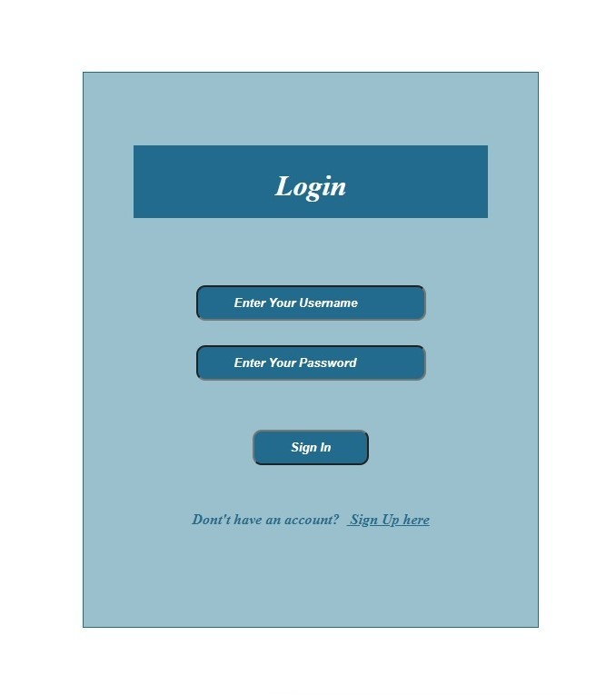

**Registration page:**

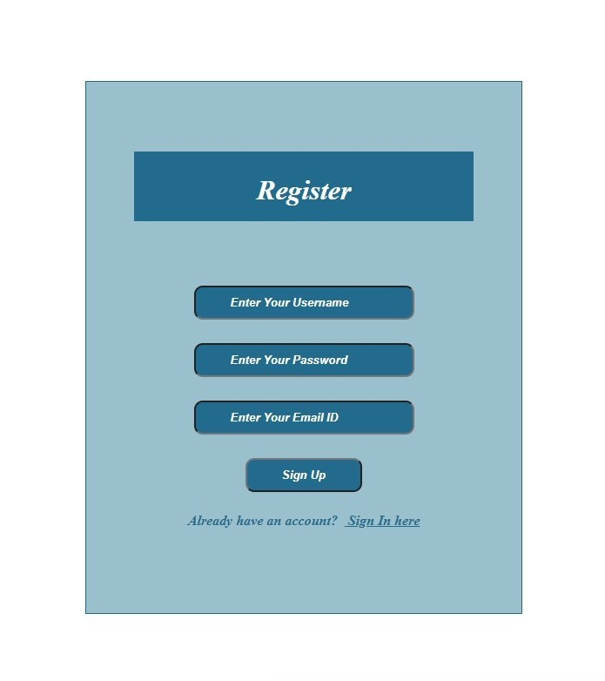

**Registration successfully:**

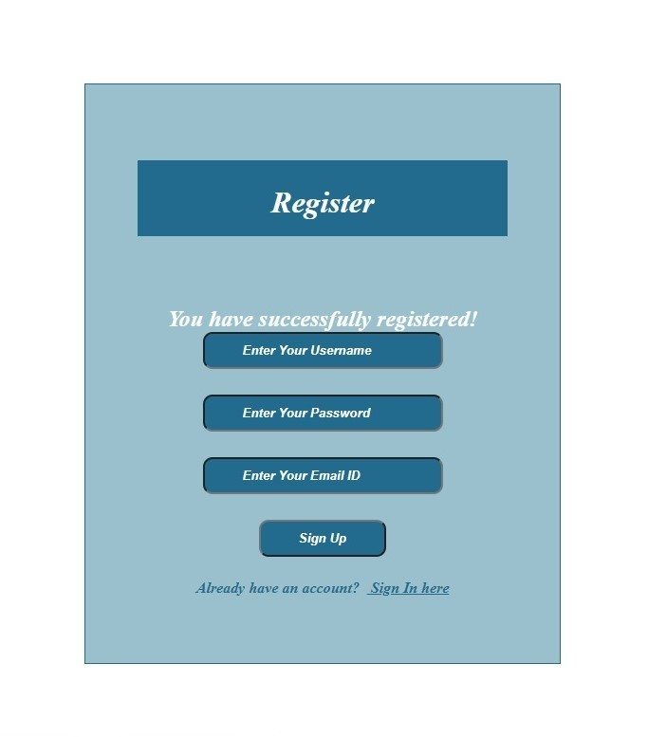

**Index page:**

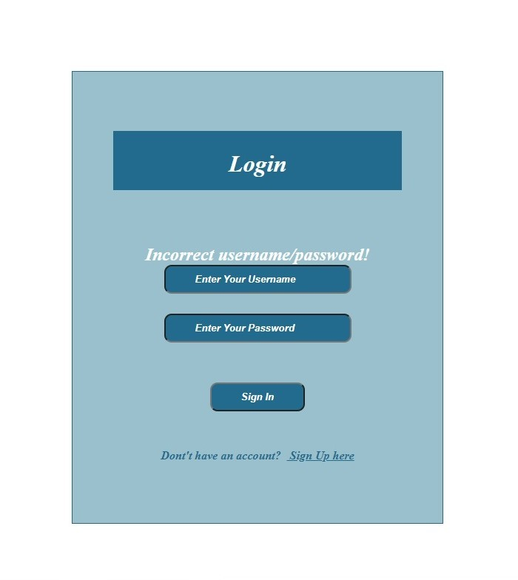

**Roadmap**

